Ecological processes in an Oak tropical montane forest and its implications on plant composition.
Barú Project Report
February-July
2015

General report

After extensive exploration of Finca El Velo four locations were selected to establish 1 ha plots (Fig. 1). The principal criterion used to choose each site was the requirement that it accommodate a square one hectare plot. Forest condition was also important for the selection; we excluded areas that contained apparent secondary forest (evidence of previous logging) and excluded areas with very dense bamboo. To sample as completely as possible the entire elevational gradient present at El Velo, plots were established at the lowest point possible (1900 m a.s.l) and at the highest elevational point of the property (2900 m a.s.l). The plot locations are named Mirador, Casita, Top and Copete

Figure 1. Location of the four 1ha plots established in Finca El Velo (Boquete, Panama).

The four 1ha plots were established using the methodology described in our initial proposal. Plots were oriented north and gridded using an x-y coordinate system, such that the southwest point is 0,0; southeast is 100,0; northwest 0,100 and finally northeast point is 100,100. To make it easier to navigate within the plot every 20*20 m sub-plot was marked with a PVC tube with vinyl flagging and a tag that indicates its x-y coordinate (indicated as red points in Fig. 2). In addition, every 5*5 m quadrat has a smaller PVC tube.

Figure 2. Final grid representation to the 1ha plots delimitation. 0,0 point is the southwest of the plot. Red points indicate the 20*20 m PVC tubes that are marked with x-y coordinates.

All trees with ≥ 2.5 cm DBH (diameter at breast height or 1.3 m) were measured and tagged. For trees with DBH ≤12 cm the tag was attached to the tree at the base using stretchable green vinyl grafting tape, long enough to last until the next census. For trees with DBH >12 cm the tag was nailed to the trunk at breast height using an aluminum nail.
Where possible, trees were identified in the field. If identifications were uncertain, trees were given a preliminary 'morphospecies' identification. To ensure that identifications are accurate, and comparable across sites botanical specimens and leaf tissue samples were taken from multiple representatives of each species and morphospecies. Botanical collections refer to a fertile (flowers and fruit if possible) sample from each plot. Pictures were taken to the fertile samples to help identification in the future (some examples are given in Fig. 3). Thus far we have completed collections of 112 fertile and 116 infertile samples of trees, shrubs, lianas and some herbs. For future DNA barcode sequencing (sequencing of a variable gene region that corresponds to species level genetic differences), samples from one leaf of the botanical collection were dried in silica gel at the time of collection. So far there are at least 152 DNA samples preserved for future analyses.

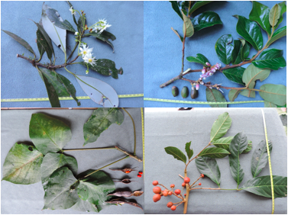
Figure 3. Botanical samples of species collected from the plots established in Finca El Velo. Species collected in Copete: A. Drymis sp. B. Symplocos sp. and species collected from Mirador: C. Erythrina sp. D. cf Ruagea sp.

The location of the plots within Finca El Velo is shown in Fig. 1, and geographic and UTM coordinates are given in Table 1. Coordinates correspond to the southwest point of each plot. The location of three of the plots (Mirador, Casita and Top) is near the gator trail so the time estimated to get to the plots is about 10 minutes (to Mirador) and 30 minutes (to Casita and Top). The farthest plot is Copete, about 1 hour and 30 minutes from where the gator trail ends. Near the Copete plot, a small temporary camp was established to provide access to the area. No trees were cut to establish the campsite. Instead, dead bamboo was cleared to provide space for a couple of tents, a latrine and a kitchen area. The camp was left for a possible future use.

Table 1. Coordinates for the four plots established in Finca El Velo. Coordinates locations refer to the southwest point (0,0) of each plot.
 | UTM (zone:17P) |  | Geographic
Plot | Easting | Northing | Lon | Lat
Mirador | 335425.00 | 975728.00 | -82.496427 | 8.82403675
Casita | 335095.48 | 974486.82 | -82.499377 | 8.81280197
Top | 333962.00 | 974377.00 | -82.509677 | 8.81176773
Copete | 333276.90 | 974045.00 | -82.515892 | 8.80874073

Results

Mirador

This plot is located in the lowest elevation (1987 m a.s.l; Fig. 1). Mirador is composed of a mixed montane forest unlike the other plots that are typical montane oak forests (Fig. 4). The plot is dominated by Styrax sp. (16% of the stems) and although there are some Quercus (oak) trees, they are not dominant in the plot (0.8% of the total stems). Along with Styrax sp., Malvaviscus sp., Psychotria sp. and Cornus sp. are the most abundant species in this area. A total of 61 morphospecies from 28 families were identified, of which 25 are identified at least to genus (Table 3 and 4). Compared with the other three plots, Mirador has the highest species richness values (Fisher´s α=14.32; Table 2).
A total of 998 stems were measured and tagged. As with all the plots, the diameter at breast height (DBH) distribution is right-skewed, with the majority of trees ranging from 5 to 10 cm DBH, a few trees were in the range between 20 and 80 cm and just a couple of trees >80 cm. The largest trees of the plot belong to Magnolia sp. (between 109.0 cm and 135.8 cm DBH). The topography of the area has slopes ranging from 0 to 41º (Fig. 6).

Table 2. General information about four 1 ha plots established inside Finca el Velo.
 | Mirador | Casita | Top | Copete
Elevation (m a.s.l) | 1987 | 2248 | 2599 | 2923
Fisher´s α | 14.32 | 9.68 | 12.59 | 7.55
No. stems | 998 | 1519 | 1152 | 879
No. Families | 29 | 26 | 31 | 26
No. Morphospecies | 61 | 50 | 57 | 36
Basal Area (m²/h) | 47.93 | 51.73 | 59.25 | 59.20

Casita

This plot is a typical oak forest (Fig. 4). Although Quercus is not the most abundant species in terms of number of individuals, it accounts for the largest trees in the plot, and therefore a high contribution to forest basal area. The Quercus species in this plot appears to be different from the Quercus sp. from the plot in higher elevations (Top and Copete) but is the same species as in Mirador plot. Styrax sp., Cleyera sp. and cf. Rogiera sp. are the most abundant species in the plot (12.2%, 12.04% and 11.78% of the total stems respectively). Fifty morphospecies within 25 families were recorded in the plot, of which only 24 are identified at least to genus (Table 3). Casita plot has an intermediate species diversity index with respect to the other three plots (Fisher´s α = 9.68; Table 2). The largest tresses are Querus sp. (111.6 cm and 102.0 cm DBH; Fig. 5). The topography of the area has slopes ranging from 0 to 32º (Fig. 6).

Figure 4. Forests at Finca el Velo along an elevation gradient. The plots Casita, Top and Copete represent oak forest where the most abundant species, and the largest contribution to forest basal area are from Quercus spp. These plots also contain species associated with typical oak forest: Viburnum sp, Styrax sp, and Cornus sp. The understory is dominated by bamboo (Chusquea sp.). The Mirador plot represents a mixed forest and is dominated by Styrax and large individuals of Magnolia sp.

Top

This is an oak forest (Fig. 4) dominated by large individuals of a single Quercus species (14.4% of stems), that occurs both at Top and Copete. The most abundant species are Ardisia sp., Psychotria sp. and Styrax sp. In total, 57 morphospecies have been recorded, representing 30 families, of which 27 have been identified to genus (Table 4). The Top plot has relatively high species richness compared to the other plots (Fisher´s α= 12.59; Table 2).
A total of 1152 stems were measured and tagged. DBH distribution is the same as in the other plots (Fig. 5). The largest trees belong to Quercus sp. (138.8 cm and 127.8 cm DBH).
The topography of the area has slopes ranging from 0 to 40º (Fig. 6).

Figure 5. Distribution of the DBH among four 1 ha plots, the y axis is the frequency of trees within each DBH range. For all the plots the DBH show a right-skewed distribution.

Copete

The area is a typical oak forest (Fig. 4), located in the highest elevation (2923 m a.s.l; Fig. 2), and is dominated by one Quercus species (35% of the stems). The most common trees in this plot are Viburnum sp, Zanthoxyllum cf. melanostictum, Schefflera sp., an unknown Asteraceae and Symplocos sp. A total of 36 morphospecies were registered, representing 25 families, with 23 taxa identified at least to genus (Table 3, 4). In terms of species diversity, Copete plot showed the lowest Fisher´s α (7.55; Table 3). The understory is open, with large canopy gaps resulting from the die-off of Chusquea bamboo last year, according to local knowledge.
A total of 879 stems were measured and tagged, representing the lowest abundance of stems across the plots. Distribution of the diameters show that the majority of trees are between 5 and 20 cm DBH, following by 20 to 80 cm, and finally low frequency of trees have more than 60 DBH (Fig. 5). The biggest trees belong to Quercus (118.3 cm DBH) and Alnus (95.5 cm DBH), although Alnus was not among the most abundant species.
The topography of the area has slopes ranging from 0 to 40º (Fig. 6).

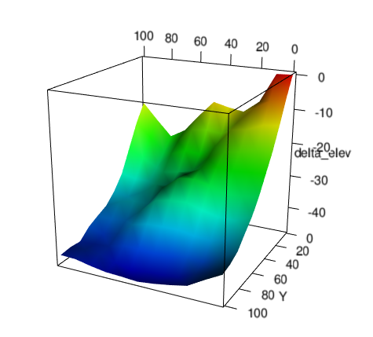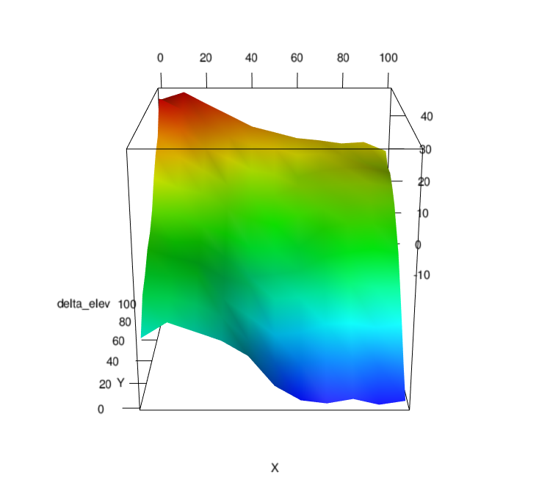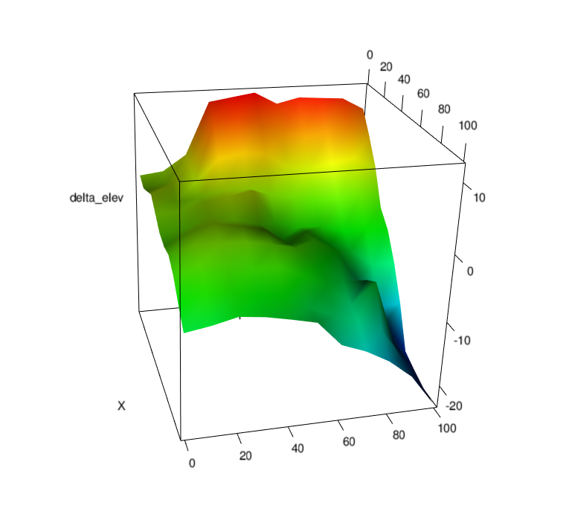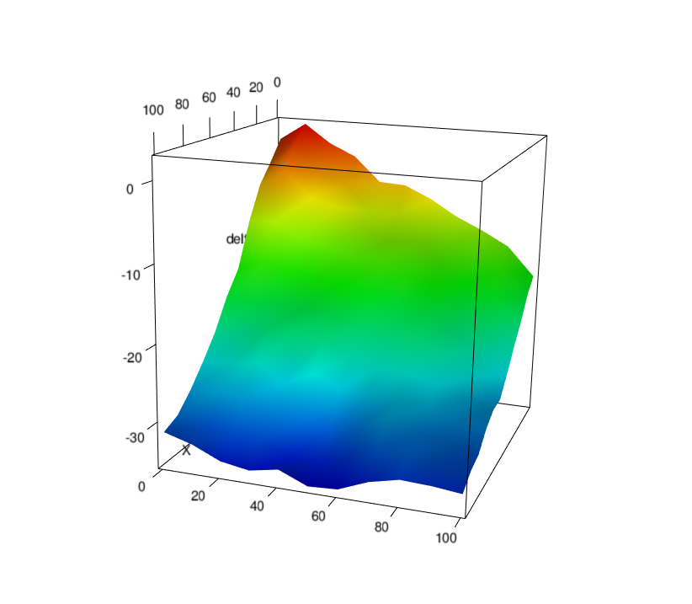

Mirador
Copete
Top
Casita

N

N

N

N
Figure 6. 3D representation for the local topography of four plots established at Finca El Velo. Y-axis represents the difference in elevation of each 10*10 m point. Values in red are in higher elevations while blue points are lower with respect to those points. x and z-axis represent the 10*10 m from which topographic data was measured.

Table 3. List of genus for four 1 ha plots in Finca El Velo. Numbers indicate abundance (number of individuals) of the genus in each plot.
 | Mirador | Casita | Top | Copete
Alnus sp | 1 | - | 3 | 9
Ardisia spp | 19 | 265 | 218 | -
Billia rosea | 11 | - | - | -
Bocconia sp | - | - | - | 1
Carica sp | 9 | - | 1 | -
Cedrella sp | 3 | - | - | -
cf. Miconia sp | - | - | - | 4
cf. Rogiera spp | 24 | 179 | - | -
cf. Solanum sp | - | - | - | 2
cf. Myrsine sp | - | - | - | 5
cf. Trichilia spp | - | - | 18 | 5
Cleyera sp | 32 | 183 | - | -
Clusia sp | - | 10 | 8 | -
Cornus sp | 63 | 16 | 50 | 5
Croton sp | 1 | - | - | -
Citharexylum sp | 12 | - | 4 | -
Dendropanax spp | - | 48 | 4 | -
Drymis sp | - | - | - | 4
Erythrina sp | 6 | - | - | -
Faramea sp | - | - | 111 | -
Gaiadendron sp | - | - | 1 | 48
Hedyosmum mexicanum | - | - | 1 | 20
cf. Heliocarpus | 1 | - | - | -
Ilex sp | - | 40 | 8 | -
Inga sp | 13 | 4 | - | -
Magnolia sp | 35 | 4 | 1 | -
Malvaviscus sp | 100 | - | - | -
Meliosma sp | 4 | 34 | 67 | 15
Myrsine sp | - | 22 | 12 | -
Palicourea cf. angustifolia | - | - | - | 1
cf. Psychotria spp | 84 | - | 88 | -
Piper sp | 27 | - | 3 | 1
Prestoea sp | - | - | 2 | -
Prunus sp | 3 | 2 | 2 | -
Quercus sp1. | - | 15 | 166 | 315
Quercus sp2 | 4 | 145 | 2 | -
Rhamnus sp | - | 3 | - | 8
Sapium sp | 8 | - | - | -
Saurauia sp | 3 | 24 | 2 | -
Schefflera sp | 30 | 20 | 35 | 65
Styrax sp | 160 | 186 | 82 | 12
Symplocos sp | 3 | 4 | 42 | 35
Turpinia sp | - | 4 | 1 | 3
Viburnum sp | 5 | 125 | 10 | 144
Weinmannia sp | - | 50 | 30 | 27
Zanthoxyllum cf. melanostictum | - | 2 | 48 | 82
Unknown | 421 | 311 | 133 | 64
TOTAL | 26 | 22 | 28 | 22

Table 4. List of families for the four 1ha plots established in Finca El Velo. Numbers represent the abundance (number of individuals) of trees within each plot for each family.
 | Mirador | Casita | Top | Copete
Actinidaceae | 3 | 24 | 2 | -
Adoxaceae | 5 | 125 | 10 | 144
Aquifoliaceae | - | 40 | 8 | 4
Araliaceae | 55 | 68 | 39 | 65
Arecaceae | - | - | 2 | -
Asteraceae | 5 | - | 2 | 40
Betulaceae | 1 | - | 3 | 9
Burseraceae | 4 | - | - | -
Caricaceae | 9 | - | 1 | -
Chloranthaceae | - | - | 1 | 20
Clusiaceae | - | 10 | 8 | -
Cornaceae | 63 | 16 | 50 | 5
Cunoniaceae | - | 50 | 30 | 27
Cyatheaceae | 1 | - | - | -
Ericaceae | - | 57 | 16 | -
Euphorbiaceae | 11 | - | - | -
Fabaceae | 19 | 4 | - | -
Fagaceae | 8 | 160 | 168 | 315
Indet | 26 | 34 | 14 | 5
Lauraceae | 86 | 26 | 91 | 9
Loranthaceae | - | - | 1 | 48
Magnoliaceae | 35 | 4 | 1 | -
Malvaceae | 120 | - | - | -
Melastomataceae | 65 | 1 | 4 | 4
Meliaceae | 25 | 2 | 18 | 5
Myrtaceae | 45 | 3 | - | 7
Pentaphylacaceae | 32 | 183 | - | -
Piperaceae | 27 | - | 3 | 1
Primulaceae | 19 | 287 | 230 | 5
Rhamnaceae | - | 3 | - | 8
Rosaceae | 3 | 2 | 2 | -
Rubiaceae | 137 | 190 | 200 | 1
Rutaceae | - | 2 | 48 | 82
Sabiaceae | 4 | 34 | 67 | 15
Sapindaceae | 11 | - | - | -
Solanaceae | - | - | 4 | 6
Staphyleaceae | - | 4 | 1 | 3
Styracaceae | 160 | 186 | 82 | 12
Symplocaceae | 7 | 4 | 42 | 35
Verbenaceae | 12 | - | 4 | -
Winteraceae | - | - | - | 4
TOTAL | 29 | 26 | 31 | 26

Future studies

The plots established at Finca el Velo provide the foundation for future work that will allow us to understand the drivers of tropical montane forests dynamics, and potential responses to predicted climate change. In combination with our existing plot network at Fortuna we have now an elevational gradient that spans from 800 m. a.s.l to 2900 m a.s.l with high species turnover (encompassing >700 tree species), and substantial variation in temperature and rainfall.
The El Velo plots will also allow us to further explore the effects of biogeochemistry on the composition and productivity of montane forests. Although we have not yet initiated soils work at the El Velo the expectation is that the soils will be relatively phosphorus rich and nitrogen poor. Given that ash deposits 8,000-13,000 years old likely encompass the entire site (Sherrod et al. 2007), soil properties are predicted to be relatively homogeneous across sites. If this is confirmed by future soils analysis, then El Velo will be a particularly important site for exploring how climate variables determine productivity, carbon storage and soil processes.

Now that the plots are established we outline the future steps to complete the initial description of the site:

- Species ID: To be able to compare the new plots with the ones that already exist not only in highlands but also in lowlands it is important to have accurate identifications of the samples to the lowest taxonomic level possible. Knowing all the species in the plot will also help us to organize a database of plant functional traits (characteristics of plants that correlate with growth, productivity and habitat requirements). To achieve this we will work initially with our fertile specimens at the UNACHI herbarium in David, University of Panama herbarium in Panama City, online herbarium resources, and with the largest neotropical plant collection (Missouri Botanical Garden).

- Aboveground biomass: To estimate aboveground biomass and carbon storage requires not only forest basal area, but also measures of wood density and tree height. Estimates of forest productivity can be made from 5 year recensuses of marked trees, but these do not reveal the substantial interannual variation in growth that is climate-related. We therefore propose to return to the plots Spring 2016 to measure tree heights, core a sample of trees from outside the plots, and install dendrometer bands on a stratified random subset of 50 trees per plot. Dendrometer bands are permanently attached to a tree and can be relatively cheaply constructed, and are read every 6 months or each year. Using height and diameter measurements we will use allometric equations in combination with wood density measurements to estimate above ground biomass and carbon storage.

- Nutrient cycling: A missing part of the characterization of the forest is detailed measurements of soils. This part of the study is important since it will provide information of the nutrient availability and other soil characteristics important for plant growth. We will take soil samples from each plot following the methodology used in our previous plot work. These soil samples will be analyzed in Ben Turner´s lab at STRI and will provide a measurement of pH, soil nutrient stocks, plant available nitrogen, phosphorus and base cations, hydrolytic and oxidative enzyme activity, and soil carbon pools. In addition to samples collected up to 50 cm depth within the plots, we will also dig a soil pit to 2 m depth beside each plot. The soil pits will provide data on deeper soil layers for the calculation of soil nutrient and carbon stocks and are essential for soil classification. The anticipated outcome of this work will be a measure of soil and biomass carbon storage for the four plots, a classification of the soils based on USDA soil taxonomy classes and data on the availability of a suite of soil nutrients essential to plant growth.

- Functional traits: Functional traits are important characteristics of the plants that reflect their capacity to perform under certain conditions.
Traits like SLA (specific leaf area), nutrient content, wood density and seed size are relatively invariant within species, making them an important point of comparison between systems with high species turnover and so with different environmental conditions. Since functional traits are important to make site comparison studies we will collect the most important traits proposed for tropical montane forests in a recent workshop that we hosted at Fortuna and El Velo.
To measure SLA and nutrient content we will collect sun leaves from 5 of the dominant species in each plot with an APTA (Air Powered Tree Access) to have better access to the canopy leaves.
To measure wood density we will take a wood sample of the same species selected to install the dendrometer bands.

After the first field season, with a more clear perception of the advantages of Finca El Velo as a field research station, many more questions have come to mind in order to understand the processes that are driving species composition in montane oak forest. Conditions of the area are suitable for initiating long-term manipulative experiments. Manipulative experiments will give us the potential to alter some environmental variables while maintaining others constant.
A key feature of El Velo that is likely to have large impacts on regeneration and carbon storage is the dominance of bamboo (Chusquea sp) in the forest understory. Bamboo dominance at El Velo is associated with low woody plant basal area and limited forest regeneration. One particular opportunity that is available now is to explore how forests respond to bamboo die-off following mass-flowering, an event that only occurs every ~ 60 years. It will be interesting to follow the consequences of this event on the plant community, species colonization and nutrient cycling. Potentially we could also combine study of this die-off event in the high elevation forest, with manipulations of bamboo cover at lower elevations to explore the impacts of above- and below-ground competition between trees and bamboo.

Budget

Table 6 shows a summary of the expenditures from the Patricia Peterson Foundation grant to accomplish the first field season January to July 2015. An attached Excel file has the details of each item in the budget, which is administrated by the Smithsonian Tropical Research Institute (STRI). Table 7 provides a tentative estimate of the budget for the second field season.

Table 6. Expenses incurred in the first field season for the project Volcán Barú.
Item | Amount
Income | $26,380.00
Salaries  One Research assistance  One permanent field assistant  One field assistant (2 months) | $17,086.51
Materials | $4,378.56
Others (pool benefits and XIII month payments | $2,182.80
Total of Expenses | $23,647.87

Table 7. Proposed budget for 2016

Item | Amount
Salaries  One Research assistance  One permanent field assistant  One non permanent field assistant | $ 10,800 (1.800*6 months)  $ 4,800 (800*6 months)  $ 1,050 (30*35 days)
Materials  Dendrometer bands  Increment borer  Soil analysis  General materials | $200 (1*200 bands)  $200  $4,000 (50*(20 samples*4plots))  $400
Others  ANAM Permits  Car expenses  Transportation for assistants  Assistants insurances & STRI fees | $ 200  $ 600 (100*6 months)  $ 1,200 (600*2)  $ 200
Total of Expenses | $23,650

